|  |  |  |  |  |  |  |  |
| --- | --- | --- | --- | --- | --- | --- | --- |
| **CBSE Roll Number** |  |  |  |  |  |  |  |

**SOCIAL BALUNI PUBLIC SCHOOL**

**AISSCE (Practical) 2020-2021**

**Biology (044)**

**Class XII**

**SET I**

**Time allowed: 3 Hours Maximum Marks: 30**

1. **Major Experiment 5 Marks**

Isolate DNA from the given plant sample. Write down the aim, requirements, procedure, observation and discussion for the experiment.

1. **Minor Experiment 4 Marks**

You are given a water sample. Study the pH and clarity of the given water sample. Write down the aim, observation and discussion for the experiment.

1. **Slide preparation 5 Marks**

You are given one flower with pollen grains. Study the process of pollen germination on slide. Write down your observation, suitable diagram and necessary comments.

1. **Spottings A, B, C, D, E, F & G. 7 Marks**

Identify the spotters and write down necessary comments.

1. **Practical record + Viva voce 4 Marks**
2. **Project record + Viva voce 5 Marks**

**\*\*\* All The Best! \*\*\***

|  |  |  |  |  |  |  |  |
| --- | --- | --- | --- | --- | --- | --- | --- |
| **CBSE Roll Number** |  |  |  |  |  |  |  |

**SOCIAL BALUNI PUBLIC SCHOOL**

**AISSCE (Practical) 2020-2021**

**Biology (044)**

**Class XII**

**SET II**

**Time allowed: 3 Hours Maximum Marks: 30**

1. **Major Experiment 5 Marks**

Isolate DNA from the given plant sample. Write down the aim, requirements, procedure, observation and discussion for the experiment.

1. **Minor Experiment 4 Marks**

You are given a soil sample. Check pH and analyse the texture of the given soil sample. Write down the aim, observation and discussion for the experiment.

1. **Slide Preparation 5 Marks**

Some onions with newly sprouted root tips are given to you. Prepare a temporary mount of the root tip and study the phases of mitosis. Write down your observation, suitable diagram and necessary comments.

1. **Spottings A, B, C, D, E, F & G 7 Marks**

Identify the spotters and write down necessary comments.

1. **Practical record + Viva voce 4 Marks**
2. **Project record +Viva voce 5 Mark**

**\*\*\* All The Best! \*\*\***

SPOTTINGS (Common for both Set A and Set B)



**Spotting A (Permanent slide observation)**



**Spotting B**

**Spotting C**

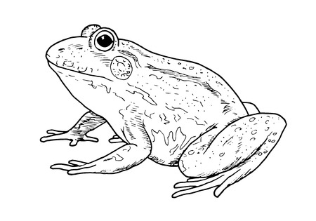

**Spotting D**



**Spotting E**

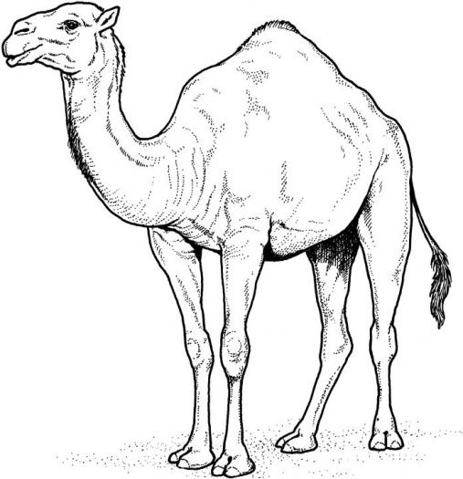

**Spotting F**

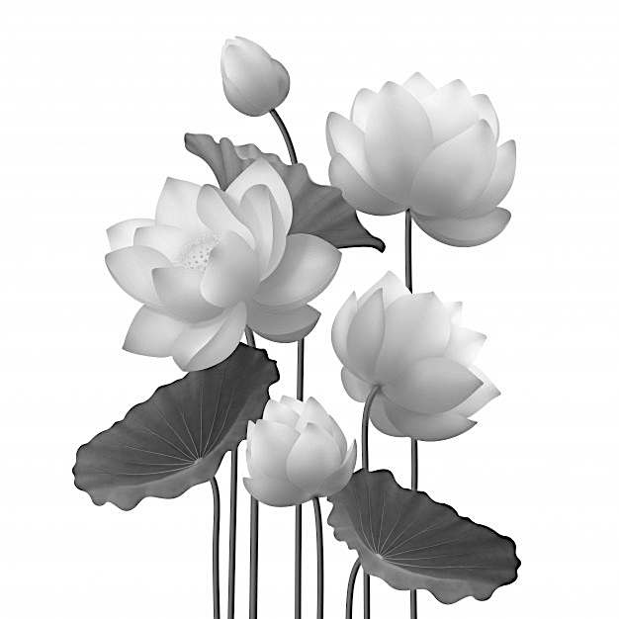

**Spotting G**